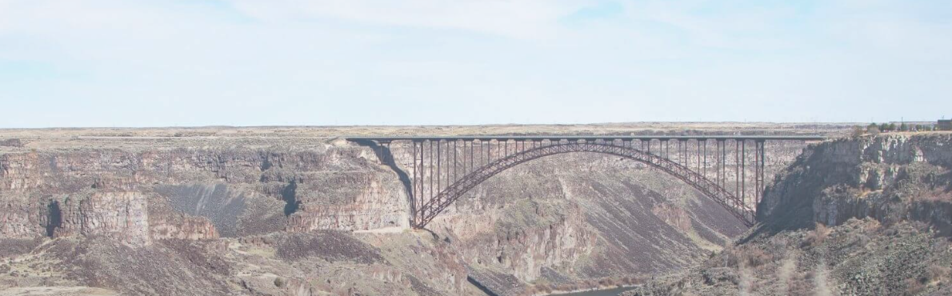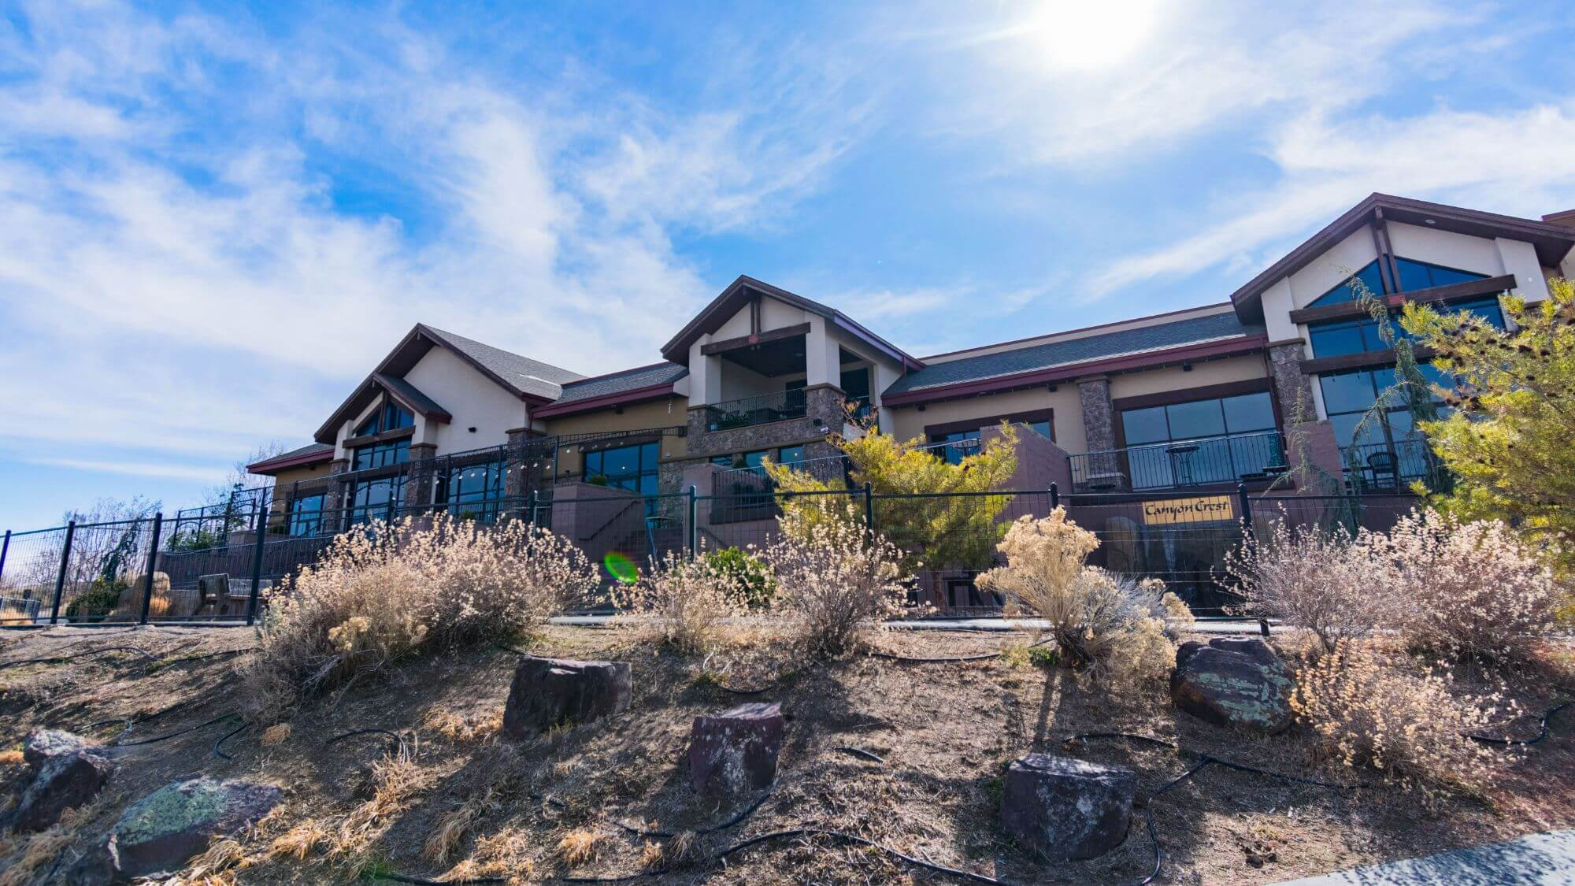

At the Canyon Crest Event Center

Northern Rockies AER 2023
October 17th-19th
Twin Falls, Idaho

Session strands are focused on benefiting students and young adults who are transitioning to adult life, individuals who are blind or visually impaired, special educators, teachers of students with visual impairments, rehabilitation and transition counselors, families, and orientation and mobility specialists.

Group rates! Marriott TownePlace Suites ($129) and Fairfield Inn & Suites ($119):
Here's your reservation link your guests can use to make reservations:
LINK for your group rate for Northern Rockies Association of Education and Rehabilitation of the Blind and Visually Impaired

Conference Rates $200 AER members/$275 non-members (includes two lunches and Dinner Wednesday).

Exhibitors: Please email tina.johnson@iesdb.org to reserve space!

Schedule at a Glance:
OCT 17th 4-7 pm Registration, with social hour to follow.
OCT 18th 8 am-5 pm Keynote and breakout sessions. 5pm optional tour of Evil Knievel jump site.
OCT 19th, 8-4:30 pm breakout sessions with optional tour of the Idaho School for the Deaf and the Blind in Gooding Idaho with social/dinner to follow.

MANY INTERACTIVE SESSIONS COVERING TRANSITION, SUCCESS IN THE WORKPLACE, AT, O&M, ECC, MULTIPLE SENSORY NEEDS/COMMUNICATION, AND CVI/NVI:

Other travel considerations: The nearest regional airport is Twin Falls, (TWF) and the nearest Int’l airport is Boise, Idaho (BOI) which is 115 miles away.

For all inquiries, please contact planning chair Tina Johnson at tina.johnson@iesdb.org.

