BEARCAT
EXPRESS

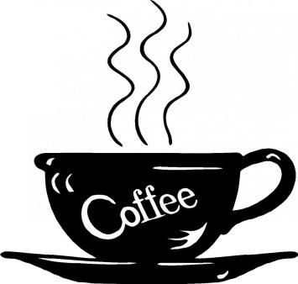
HOT DRINKS:
Cappuccino 2.00 Black Coffee 1.00
Latte 2.00 Diesel 2.00
Chai Latte 2.00 Apple Cider 2.00
Chai Tea 2.00 Hot Chocolate 1.00

Steamer 2.00

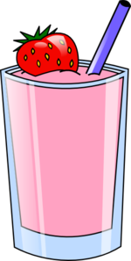
COLD DRINKS:
Smoothie (no Coffee) 2.00 Chai Tea 2.00
Real Fruit Smoothies 2.50 Ice Tea 1.00
Slide (with Coffee) 2.00 Sweet Tea 1.25
Italian Soda 2.00 Sparkling Tea 2.00
Frozen Hot Chocolate 2.00 Protein Shake 2.00
Iced Coffee 2.00 Real Fruit Protein Shake 2.50

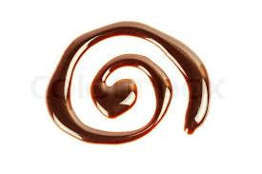
EXTRAS:
Extra Shot .25 Chocolate Swirl .25
Extra Whip Cream .50 Caramel Swirl .25

**We Use Fat Free Milk In All Of Our Drinks**
Enjoy!

