ACTIVITY: Aligning MTSS and Other School/District Initiatives
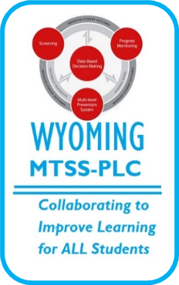

Directions: With your team, identify connections between school/district initiatives and implementation of the essential components of MTSS. Consider ways these initiatives support implementation of MTSS and how MTSS supports implementation of these initiatives. After the team has identified connections, identify 2-3 strategies to improve the alignment between MTSS implementation and other initiatives in the school/district. Use the action planning template to develop and record your action steps for implementing these strategies.

MTSS Essential Components | ESSA | Wyoming Dyslexia Bill Requirements | School Improvement/ Continuous Improvement | Specific Learning Disability (SLD) Eligibility | Other:
Universal Screening
Progress Monitoring
MTSS Essential Components | ESSA | Wyoming Dyslexia Bill Requirements | School Improvement/ Continuous Improvement | Specific Learning Disability (SLD) Eligibility | Other:
Tier I
Tier II
Tier III
MTSS Essential Components | ESSA | Wyoming Dyslexia Bill Requirements | School Improvement/ Continuous Improvement | Specific Learning Disability (SLD) Eligibility | Other:
Data Decision Making
Infrastructure and Support Mechanisms
Fidelity & Evaluation
TEAM ACTION PLANNING

What can we do to improve the alignment between MTSS implementation and other school/district initiatives (AKA, goals)? | What steps can we take to implement these changes (AKA, action steps)? | What resources do we need? Who will help with this work? | What is our timeline?

